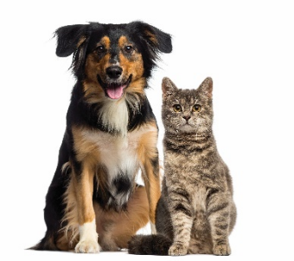
VETLINK MOBILE IMAGING REFERRAL FORM
Requesting a Consultation with VetLink
- Please fill in the fields below and email this form, along with any additional information, to info@vetlinkmobileimaging.ca
Owner and Pet Information
Owner Name
Pet Name
Pet Age (Years)
Species | Dog Cat
Breed
Sex | Female Intact Female Spayed Male Intact Male Neutered
Weight (kg - round to nearest kg)
Referring Veterinarian Information
Referring Veterinarian Name
Referring Hospital Name
Referring Hospital Address
Referring Hospital City
Referring Hospital Postal Code
Referring Hospital Phone Number
Referring Hospital Email
Procedure Requested
Ultrasound | Endoscopy
Ultrasound - Abdomen | Endoscopy - Foreign Body
Ultrasound - Thorax | Endoscopy - Upper or Lower GI
Ultrasound - Dual Cavity | Endoscopy - Upper and Lower GI
Ultrasound - Soft Tissue
Ultrasound - Neck
Ultrasound - Urogenital
Ultrasound - Gastrointestinal
Ultrasound - Recheck

Case Information
Primary Complaint and Goal for Imaging
Brief Patient History
Previous Health Concerns
Physical Exam Findings
Medications (please include drug, current dose, frequency)
Diagnostic Findings (lab work, radiology, etc. Can upload as well)
Relevant Files: Please attach to email along with this form and send to info@vetlinkmobileimaging.ca

